Integrated Flood and Landslide Risk Assessment and Response System for Sri Lanka

Probabilistic Assessment and Forecasting of Landslide Occurrences

Project ID : J26-IT-334

Project Proposal Report
Bagya R M S – IT23394124

B.Sc. (Hons) Degree in Information Technology Specialized in
Information Technology

Department of Information Technology
Sri Lanka Institute of Information Technology Sri Lanka

September 2026
DECLARATION
I declare that this is my own work, and this proposal does not knowingly incorporate any material previously submitted for a degree or diploma at any other university or higher education institution, nor does it contain any material that has been previously published or written by another person apart from where proper acknowledgment is given in the text.

Name | Student ID | Signature
Bagya R M S | IT23394124

The above candidate is conducting research for their undergraduate Dissertation under my supervision.
Name | Date | Signature

ABSTRACT
The central highlands of Sri Lanka, particularly the Walapane, Ambagamuwa, and Kotmale regions within the Nuwara Eliya District, experience recurrent rainfall-induced landslides during monsoon seasons. Despite severe socio-economic impacts, these specific zones lack localized, dynamic early-warning capabilities compared to adjacent high-risk provinces. Current predictive frameworks often rely on static susceptibility mapping or expert-driven weighting methods, creating a critical gap in time-accurate forecasting. To address this gap, this study develops a temporal probabilistic landslide forecasting module integrated within a multi-hazard disaster risk assessment platform. Utilizing a historical landslide inventory from the National Building Research Organization (NBRO), the module trains and evaluates Logistic Regression, XGBoost, and LightGBM models. Predictive inputs fuse dynamic precipitation metrics with static geospatial variables, including Digital Elevation Model (DEM) derived slope angles, soil properties, land cover, and Rainfall. The models are validated using a 5-fold spatial block cross-validation strategy to assess out-of-sample geographic transferability. The module predicts the spatial landslide occurrence probability for a 24-hour forecast horizon across a 30-meter resolution grid, categorizing risk into five levels from Very Low to Very High. Local model interpretability and feature attributions are computed via SHAP and LIME frameworks to isolate the relative contributions of environmental and trigger factors behind specific slope failures. Ultimately, these spatial probability fields provide the baseline data required for downstream impact assessment and emergency resource allocation components.

Keywords - landslide forecasting, machine learning, spatial cross-validation, explainable AI, disaster risk reduction.

ACKNOWLEDGEMENT

I would like to express my gratitude to everyone who supported me throughout the course of this research project.
First and foremost, I extend my appreciation to my supervisor and co-supervisor for their invaluable guidance, constructive feedback and continuous encouragement throughout the development of this project. Their expertise and insightful direction were instrumental in shaping the scope, methodology and overall quality of this work.
I would also like to thank the Topic Screening Panel for their review and constructive comments during the topic assessment stage, which helped refine the direction of this research.
My sincere thanks go to the officials at the Disaster Management Centre (DMC) for their guidance in facilitating the data request process and for sharing their knowledge, which greatly informed the requirements and data-acquisition strategy for this component.
I am also grateful to the National Building Research Organization (NBRO) and the Department of Meteorology, Sri Lanka for maintaining and providing access to the landslide and rainfall data resources that form the foundation of this research.
I would like to thank my team members for their collaboration, shared effort and coordination in developing the integrated components of this project and for the collective work that made the overall system possible.
Finally, I would like to thank my family and friends for their support, patience and encouragement throughout the duration of this project.
TABLE OF CONTENT
ACKNOWLEDGEMENT 4
LIST OF TABLES 7
LIST OF FIGURES 8
LIST OF ABBREVIATIONS 9
LIST OF APPENDICES 10
1. INTRODUCTION 11
1.1 Background and Context 11
The real world problem 11
Who is affected, and why it matters. 11
Statistical evidence. 11
Analysis of existing solutions and their limitations. 11
Proposed solution and its parts. 13
SDG alignment. 13
Research cluster alignment. 13
1.2 Literature Review 14
Part A: Peer-Reviewed Literature 14
A.1 Gaidzik & Ramírez-Herrera (2021) -"The Importance of Input Data on Landslide Susceptibility Mapping" 14
A.2 Brenning (2005) - "Spatial Prediction Models for Landslide Hazards: Review, Comparison and Evaluation" 15
A.3 Gunasinghe, Gunawardhana & Rajapakse (2023) - "Predictive Analysis of Landslide Susceptibility under Hydrological Aspects of Climate Change in Kegalle District, Sri Lanka" 16
Part B :Existing Systems and Products 17
B.1 ResQConnect (Aththanayake et al., 2026) 17
B.2 NBRO/DMC Operational Early-Warning System 17
B.3 Walapane AHP Landslide Hazard Zonation Study (2018) 18
1.3 Research Gap 19
Feature 1- No comparative, locally calibrated probabilistic forecasting engine. 19
Feature 2- No continuously updated, accessible severity output at the community level. 19
Feature 3- No factor-level explanation of individual predictions. 20
2. OBJECTIVE 21
2.1 Main Objective 21
2.2 Specific Objectives 21
To acquire and compile the core landslide dataset 21
To construct a multi-factor geospatial feature set 21
To integrate human-factor risk parameters 21
To train and comparatively evaluate machine-learning classification models 21
To develop a WebGL-powered, dual-language (Sinhala/Tamil/English) live mapping interface 21
To implement an explainable-AI layer 21
3. METHODOLOGY 22
3.1 Research Methodology / Design 22
3.2 Data / Experimental Inputs 22
3.3 Baseline / Benchmark 24
3.4 Evaluation Metrics 24
3.5 Validation Strategy 25
3.6 Development Approach 25
4.HIGH-LEVEL SYSTEM ARCHITECTURE 26
4.1 Overview of Proposed Solution and its Components 26
4.3 Individual Component 28
4.4 Overall Integration 29
4.5 Individual Responsibility Boundary 30
5.USER REQUIREMENTS 31
5.1 Evidence-Gathering Activities 31
5.2 Translated System Requirements 31
Functional Requirements 31
Non-Functional Requirements 32
6. COMMERCIALIZATION PLAN 33
6.1 Target Market and Customer Persona 33
6.2 Value Proposition 33
6.3 Revenue Model 33
6.4 Cost Estimation 34
6.5 Pricing Strategy 34
6.6 Competitive Advantage 34
6.7 Intellectual Property Considerations 35
7.BUDGET AND JUSTIFICATION 36
7.1 Hardware Costs 36
7.2 Software Licenses 36
7.3 Cloud Services 37
7.4 Summary Justification 37
8. WORK BREAKDOWN STRUCTURE (WBS) 38
9. GANTT CHART 39
10. APPENDICES 42
Appendix 2 - Mandatory Proposal Evidence and Decision Log 46
Appendix 3 - AI Use Disclosure 46

LIST OF TABLES

LIST OF TABLES 6
3.4 Evaluation Metrics 23
4.5 Individual Responsibility Boundary 29
7.1 Hardware Costs 35
7.2 Software Licenses 35
7.3 Cloud Services 36
Appendix 2 - Mandatory Proposal Evidence and Decision Log 45
Appendix 3 - AI Use Disclosure 45

LIST OF FIGURES

Figure 1. Landslide incident distribution in Nuwara Eliya District following Cyclone Ditwah, showing 22 recorded incidents concentrated around Walapane and Kotmale the study area's most exposed divisions. Source: [dashboard publisher] 12
Figure 2.Tools and Software That We Going to Use to Implement Our Research Components 22
Figure 3.architecture diagram, black-and-white, own component highlighted 26
Figure 4.System Architecture Diagram Integrated Flood and Landslide Risk Assessment and Response System for Sri Lanka 27
Figure 5.Work Break Down Chart For Whole System 37
Figure 6.Gaant Chart Of my Component 38

LIST OF ABBREVIATIONS

Abbreviation | Full Form
AI | Artificial Intelligence
AHP | Analytic Hierarchy Process
API | Application Programming Interface
AUC | Area Under the Curve
B2G | Business to Government
DEMs | Digital Elevation Models
DMC | Disaster Management Center
GIS | Geographic Information System
GPU | Graphics Processing Unit
PostGIS | Spatial Database Extender for PostgreSQL
SDG | Sustainable Development Goal
WBS | Work Breakdown Structure
SVM | Support Vector Machine
SaaS | Software As a Service
OSM | OpenStreetMap
NBRO | National Building Research Organization
NBRI | National Building Research Institute
LHMP | Landslide Hazard Mapping Project

LIST OF APPENDICES
LIST OF APPENDICES 10
Appendix 1 42
Appendix B: Prototype Evidence - Individual Component (Landslide Prediction) 44
Appendix C: Preliminary Research Notes (Requirements Elicitation & Research Design) 45
Appendix 2 - Mandatory Proposal Evidence and Decision Log 46
Appendix 3 - AI Use Disclosure 46

INTRODUCTION

Background and Context
The real-world problem. Sri Lanka's central highlands experience two monsoon seasons each year: the southwest monsoon (May-September) and the northeast monsoon (October-January) both of which saturate steep, weathered terrain and regularly trigger landslides, cutting failures, and slope failures. These events destroy homes, sever roads and utilities, and in the worst cases cause mass casualties, with damage that compounds each year as climate variability intensifies rainfall extremes [4].
Who is affected, and why it matters. The most exposed communities are not in Sri Lanka's major cities but in rural, plantation-dependent hill-country divisions in Nuwara Eliya District, specifically the Walapane, Ambagamuwa, and Kothmale Divisional Secretariat (DS) divisions. These areas combine steep slopes, high annual rainfall, and dense population settled directly on or below hazard-prone terrain, including estate labor communities with limited resources to relocate or rebuild after a disaster. The National Building Research Organization (NBRO) issues district- and divisional-level landslide early warnings for these exact divisions during nearly every monsoon [5], underscoring how routine and how under-resourced the exposure is.

Statistical evidence.
Global: Landslides caused over 18,000 deaths and affected 4.8 million people worldwide between 1998 and 2017, with Asia accounting for 54% of all recorded events and global economic losses reaching approximately USD 8 billion [3].
Local: Sri Lanka's central highland region recorded nearly 1,000 landslide-related deaths between 2003 and 2016 [3]. In Kegalle District alone, 13% of the land area was found to be highly susceptible to landslides and 37% prone to slope failure as of 2018 [3]. For Nuwara Eliya specifically, NBRO's own risk-profiling work has flagged Walapane and neighbouring divisions as recurring high-exposure zones, with warnings issued for Kotmale, Walapane, Hanguranketha, and Ambagamuwa in the same advisory nearly every rainy season [5].
Analysis of existing solutions and their limitations. Current landslide-risk approaches fall into three broad categories, each with a specific shortfall relevant to this component:
1. Heuristic, expert-weighted zonation (AHP-based). Studies conducted directly in Nuwara Eliya's Walapane division have produced landslide hazard zonation maps using the Analytic Hierarchy Process across six static factors: slope, rainfall, soil type, land use, geology, and land-use change, classified into fixed low/moderate/high risk bands [5]. A similar AHP approach applied in Kegalle District improved accuracy from a 50–70% rainfall-only baseline to 86% by incorporating five additional factors [3]. These approaches are valuable and locally grounded, but they rely on subjectively assigned expert weights rather than models trained and validated against actual outcome data, and they produce static, seasonal risk maps rather than a continuously updated occurrence probability.
2. Data-driven statistical/ML susceptibility mapping (international literature). Research using large landslide inventories has shown that model accuracy depends heavily on the type of inventory used (manual vs. automatic), the resolution of the topographic data, and the number of causative factors included with AUC varying by as much as 0.2 across similar models [1]. Separate work has shown that simpler classifiers such as logistic regression often generalize better outside their training area than more complex machine-learning methods like SVM or bootstrap-aggregated trees, which tend to overfit [2]. This body of work establishes a sound comparative methodology, but it has been developed and validated in Mexico and Ecuador respectively, not calibrated to Sri Lankan terrain, soils, or monsoon rainfall behavior, and none of it is built for real-time forecasting.
3. Government early-warning systems (NBRO/DMC). Sri Lanka's operational disaster warnings are issued at the district or DS-division level [4]. The Disaster Management Centre alone publishes dozens of separate bulletins daily throughout the monsoon season weather forecasts, water-level and rainfall reports, and landslide early-warning reports reissued multiple times a day [5]. While this reflects a genuinely active and responsive warning operation, it is fundamentally reactive and threshold-based rather than predictive: bulletins report conditions as they occur or are imminently expected, rather than forecasting a probability of landslide occurrence ahead of time at the level of a specific slope or settlement. The scale of what this reactive model is up against was made starkly clear by Cyclone Ditwah, which in late 2025 triggered the most extensive flooding and landslide damage Sri Lanka had seen in two decades - 646 fatalities, 173 people missing, approximately 2.2 million people affected across all 25 districts, and displacement camps specifically established in Nuwara Eliya district [6].
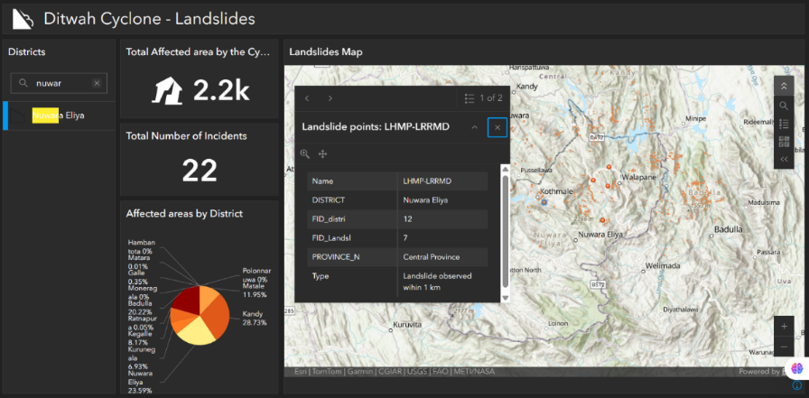
Taken together, no existing solution heuristic, data-driven, or operational combines locally calibrated, comparative machine learning with a real-time occurrence probability, transparent factor-level explanation, and an interface genuinely accessible to the communities who receive these warnings. This is the gap the proposed component addresses.

Figure 1. Landslide incident distribution in Nuwara Eliya District following Cyclone Ditwah, showing 22 recorded incidents concentrated around Walapane and Kotmale — the study area's most exposed divisions. Source: [dashboard publisher]

Proposed solution and its parts. This component addresses that gap with three integrated parts: (1) a multi-factor probability engine that correlates rainfall, soil type, historical landslide inventory, and slope angle (derived from DEM data), comparatively evaluating multiple ML models to generate a landslide occurrence probability value for each relevant area, which is then classified into five susceptibility tiers Very Low, Low, Moderate, High, and Very High for interpretability; (2) an inclusive, Multi-language Web-GIS live mapping interface with high-contrast, accessible themes for elderly and village-level users; and (3) an explainable-AI layer (SHAP/LIME) that breaks down each prediction into the specific environmental and human factors driving it, moving from broad regional alerts toward site-specific, actionable warnings.[8]

SDG alignment. This work aligns primarily with SDG 11 (Sustainable Cities and Communities), specifically Target 11.5, which calls for significantly reducing deaths and economic losses from disasters, and SDG 13 (Climate Action), Target 13.1, which calls for strengthening resilience and adaptive capacity to climate-related hazards. It also contributes indirectly to SDG 3 (Good Health and Well-being) by reducing disaster-related casualties, and SDG 9 (Industry, Innovation and Infrastructure) through resilient, technology-enabled infrastructure planning.

Research cluster alignment. This component aligns with SLIIT's Center of Excellence for AI (CEAI), a multidisciplinary initiative advancing applied AI research across the university. The component's core contribution is a comparative evaluation of multiple machine-learning models for probabilistic disaster forecasting, paired with an explainable-AI layer (SHAP/LIME) that renders model predictions transparent and interpretable sits squarely within CEAI's focus on applied, real-world AI systems rather than purely theoretical model development. By grounding the research in a locally calibrated, high-stakes application domain (landslide occurrence prediction for a specific, historically underserved district), this component also reflects CEAI's broader emphasis on AI research that produces measurable societal impact, consistent with the multidisciplinary, solutions-oriented approach the center is built around.

Literature Review

Part A: Peer-Reviewed Literature

A.1 Gaidzik & Ramírez-Herrera (2021) -"The Importance of Input Data on Landslide Susceptibility Mapping"
- Method: Logistic regression was used to build 32 separate landslide susceptibility models, systematically varying four input factors: landslide inventory type (manual vs. automatic), DEM resolution (15 m vs. 1 m), number of causative factors (12 vs. 15), and landslide sampling technique (mass vs. mass-center) to isolate which most strongly affects model accuracy.
- Dataset: Two study regions in the Cayuca River basin, southwest Mexico (15.6 km² and 6.7 km²); landslide inventories built from both manual satellite-image interpretation (419 landslides) and an automated Contour Connection Method (1,726 features), calibrated against 15 m and 1 m resolution DEMs
- Context: Tropical, hurricane-prone, mountainous terrain geomorphologically comparable to Sri Lanka's central highlands, though on a different continent and under a different rainfall regime.
- Findings: Models based on automatic landslide inventory achieved comparable overall prediction accuracy to those built from manually detected features, and finer-resolution topographic data produced more accurate and precise susceptibility models. Sampling from the full landslide mass rather than just its center point consistently produced more reliable models, with AUC values differing by up to 0.2 depending on configuration.
- Strengths: A rigorous, controlled comparison that isolates single variables genuinely useful for justifying why specific model design choices (inventory type, resolution, sampling method) matter, and it provides defensible accuracy benchmarks to compare this component's own results against.
- Limitations relative to this research: A single-algorithm study (logistic regression only) with no comparative ML evaluation; not designed for real-time use; not calibrated to a Sri Lankan or tropical-monsoon-village context; produces static maps rather than a live, continuously updated probability feed.
- Influence on proposed research: This study directly motivates the comparative multi-model design (XGBoost, LightGBM, logistic regression) and the emphasis on data-quality decisions inventory source, resolution, sampling as first-class methodological choices rather than afterthoughts.

A.2 Brenning (2005) - "Spatial Prediction Models for Landslide Hazards: Review, Comparison and Evaluation"
- Method: Comparative evaluation of logistic regression (with and without stepwise variable selection, and with spatial-autocorrelation modelling), support vector machines, and bootstrap-aggregated classification trees (bagging and double-bagging), using a spatial cross-validation scheme that separates test and training points by an empirically derived distance buffer to avoid spatial-autocorrelation bias.
- Dataset: The Estación Científica San Francisco area in the Andes of southern Ecuador (11.2 km²); a multi-temporal landslide inventory compiled across five survey years (1962–1998), enabling both "present" and "future" prediction scenarios.
- Context: Tropical mountain rainforest terrain with slashing/burning and grazing-driven land-use change, a socio-environmental profile with parallels to human-driven landslide triggers (road cuts, deforestation) relevant to Nuwara Eliya.
- Findings: Logistic regression with stepwise variable selection achieved the lowest error rates and the best generalization outside the training area of all methods tested, while tree-based methods (bagging, double-bagging) substantially overfit the training data despite near-zero apparent error rates on the training set itself.
- Strengths: Provides strong, citable evidence that logistic regression is not a naive or outdated baseline but a genuinely competitive method with superior generalization properties - directly justifying its inclusion in this component's comparative model set rather than treating it as a formality.
- Limitations relative to this research: Two-decade-old dataset and toolset, predating gradient-boosted methods such as XGBoost and LightGBM entirely; no explainability layer of any kind; a research case study with no path to operational or real-time deployment.
- Influence on proposed research: Justifies retaining logistic regression as a required comparison baseline (not just a placeholder) and reinforces the importance of rigorous, spatially-aware validation (this component will need to guard against similar overfitting risks, particularly if XGBoost/LightGBM are tuned aggressively on a comparatively small Nuwara Eliya inventory).

A.3 Gunasinghe, Gunawardhana & Rajapakse (2023) - "Predictive Analysis of Landslide Susceptibility under Hydrological Aspects of Climate Change in Kegalle District, Sri Lanka"

- Method: Analytic Hierarchy Process (AHP), combining six expert-weighted factors rainfall-threshold exceedance days, slope, elevation, distance from river, soil type, and land use/land cover into a single weighted susceptibility score; future rainfall projected via the HadGEM3-GC31-LL climate model (CMIP6), statistically downscaled using LARS-WG.
- Dataset: A 1,523 km² catchment in Kegalle District, Sri Lanka; historical landslide, slope-failure, and cutting-failure records from NBRO; CHIRPS gridded rainfall data (5 km × 5 km resolution).
- Context: Sri Lanka's central highland region, directly adjacent to and climatically similar to Nuwara Eliya District, making it the most geographically relevant of the three literature sources.
- Findings: Rainfall alone matched 50–70% of observed landslide occurrences; incorporating the additional five factors raised overall model accuracy to 86%, with 25 of 29 validation events falling into "high" or "very high" risk zones. Future climate scenarios (SSP2-4.5, SSP5-8.5) project substantial expansion of high-risk zones, with high/very-high susceptibility area coverage rising from 46.95% (observed baseline) to as much as 72.97% under SSP5.
- Strengths: Directly local to Sri Lanka; demonstrates that multi-factor modelling substantially outperforms rainfall-only approaches in exactly the terrain and climate this component targets; provides a credible accuracy benchmark (86%) against which this component's ML models can be compared.
- Limitations relative to this research: Heuristic, expert-assigned AHP weights rather than weights learned from training data; no comparative evaluation across multiple algorithms; produces static seasonal maps rather than a continuously updated probability; not validated specifically for Nuwara Eliya's Walapane/Ambagamuwa/Kotmale terrain.
- Influence on proposed research: Confirms that multi-factor approaches are essential in the Sri Lankan context and gives a concrete accuracy target (86%) to benchmark against; motivates replacing subjective AHP weighting with models that learn factor importance directly from historical Nuwara Eliya landslide data.

Part B: Existing Systems and Products

B.1 ResQConnect (Aththanayake et al., 2026)
- Functions: An agentic Retrieval-Augmented Generation (RAG) pipeline that converts citizen help-request text into structured, SOP-grounded task plans; an adaptive event-triggered multi-commodity vehicle-routing engine for relief-resource distribution; a compressed, edge-deployed language model providing offline safety guidance on smartphones when connectivity fails.
- Technology: A multi-agent LLM architecture (dedicated metadata-extraction, retrieval, adequacy-assessor, and task-planner agents) built on GPT-4o for the cloud pipeline; a quantized 0.5-billion-parameter model (Qwen2.5-0.5B) fine-tuned on a curated disaster Q&A dataset and converted to MediaPipe’s task format for on-device inference.
- Performance: Improved overall task-quality scores from 61.4 to 82.9 (+21.5 points) over a standard RAG baseline; reduced routing solver calls by up to 85% compared to continuous re-optimization while remaining within 7–12% of optimal response time; delivered fully offline mobile guidance with sub-500 ms response latency and 54 tokens/s throughput on a commodity smartphone (Samsung Galaxy S23 Ultra).
- Users: Disaster-management agencies and field responders (task breakdowns, routing plans) and affected citizens (mobile chatbot for offline guidance).
- Limitations relative to this component: ResQConnect operates entirely on the response side of the disaster timeline - it assumes a hazard has already occurred and been reported by a citizen, then optimizes coordination, logistics, and guidance. It contains no predictive or probabilistic hazard-occurrence capability at all; floods and landslides are categories within its knowledge base, not phenomena it forecasts. It is also validated on aggregated national-scale Sri Lankan disaster data rather than calibrated to a specific district's terrain, soil, and historical landslide inventory.

B.2 NBRO/DMC Operational Early-Warning System
- Functions: District- and DS-division-level landslide and flood advisories, rainfall/water-level bulletins, and situation reports, issued multiple times daily during the monsoon season.
- Technology: Threshold-based triggers (e.g., the established 73 mm/day rainfall threshold used in NBRO's own landslide-triggering criteria) rather than a trained predictive model; manually compiled and distributed bulletins.
- Performance: No published model-accuracy metric (it is an advisory service, not a predictive model); operational responsiveness is high, with bulletins reissued several times per day during active weather events.
- Users: The general public, district and divisional disaster-management officials, and downstream agencies such as the DMC.
- Limitations relative to this component: Fundamentally reactive and threshold-based rather than predictive; granularity stops at the district or DS-division level, well short of a specific slope or settlement; provides no probability value, no severity tier, and no explanation of which factors are driving the risk.

B.3 Walapane AHP Landslide Hazard Zonation Study (2018)
- Functions: A static, seasonal landslide hazard zonation map for Walapane DS division, the same DS division targeted by this component, classifying land into low/moderate/high risk.
- Technology: GIS-based Analytic Hierarchy Process combining six factors: slope, annual rainfall variation, soil type, land-use change, geology, and observed landslide timing patterns.
- Performance: Risk classification produced for three high-risk months (November, December, January) based on historical landslide timing; no AUC or percentage-accuracy figure reported.
- Users: Land-use planners and local disaster-management authorities in Walapane.
- Limitations relative to this component: No machine-learning component and no comparative model evaluation; static, seasonal output rather than a continuously updated probability; despite being the most geographically precise prior study (Walapane itself), it predates the more comprehensive multi-factor approaches later validated in Kegalle [3] and offers no explainability or accessible public-facing interface.

Research Gap
Across both the peer-reviewed literature and the operational systems reviewed in Section 1.2, a consistent pattern emerges: every existing approach is strong in exactly one of three dimensions predictive rigor, real-time accessibility, or interpretability but no single system, published study, or operational tool combines all three for a locally calibrated landslide-occurrence model in Sri Lanka's central highlands. This proposed component is structured around three integrated parts specifically because each one closes a distinct, evidenced gap left open by the systems already discussed.
Feature 1 - Current literature exhibits a scarcity of comparative, locally calibrated probabilistic forecasting frameworks. While rigorous predictive methodologies exist, such as Gaidzik and Ramírez-Herrera's systematic input-data comparison [1] and Brenning's multi-classifier evaluation [2], they were validated in Mexico and Ecuador using terrain, soil, and rainfall regimes distinct from Sri Lanka. Furthermore, these studies focus primarily on a handful of classical statistical methods rather than modern gradient-boosted approaches. Conversely, localized Sri Lankan studies, such as the Kegalle AHP model [3] and the Walapane zonation study, rely predominantly on subjectively assigned expert weights rather than models trained on actual outcome data, omitting comparative model evaluations. Consequently, it remains under-explored which machine-learning approach yields the highest accuracy when trained specifically on Nuwara Eliya's distinct terrain, soil, rainfall, and historical inventory, as this specific district-level evaluation is absent from reviewed systems.
Feature 2 - A notable gap remains in deploying continuously updated, accessible severity outputs at the community level. Operationally, NBRO and DMC bulletins are constrained to the broader district or DS-division levels, while existing AHP-based studies [3, 5] yield static, seasonal susceptibility maps rather than dynamic, live metrics. These approaches seldom deliver specific probability or severity tiers down to the village level, nor are they integrated into interfaces optimized for vulnerable demographics, such as elderly and rural residents in Sinhala- or Tamil-speaking communities. While platforms like ResQConnect [4] provide citizen-facing interfaces, they function reactively after an incident has been reported, lacking a proactive mechanism to surface hazard probabilities beforehand. Therefore, further research is required to address how real-time landslide probability and localized severity tiers can be communicated directly and accessibly to at-risk communities rather than solely to regional officials.
Feature 3 - Existing susceptibility models, whether heuristic (AHP-based) or statistical (logistic regression, SVM, tree-based [1, 2]), typically output fixed weights or single aggregate probabilities, leaving a gap in explaining why a specific location is at risk. These systems generally lack the mechanism to decompose a single prediction into the relative contributions of environmental factors (such as rainfall, soil, and slope) versus human-induced factors (such as road cuts, deforestation, and drainage blockages) for an individual site. This factor-level causality remains unaddressed at the individual-prediction level within the reviewed literature.

OBJECTIVE

2.1 Main Objective
To create an Intelligent and Integrated disaster management system that identifies flood and landslide risks, estimates their impacts, and provides timely decision support and emergency response recommendations for Sri Lanka.

2.2 Specific Objectives
To acquire and compile the core landslide dataset for Nuwara Eliya District historical landslide point locations, NBRO hazard zones, and high-resolution precipitation records through formal data requests to national departments.
To construct a multi-factor geospatial feature set by layering DEM-derived slope angle, bedrock/soil classification, and rainfall trigger thresholds (based on official NBRO alert levels) within a spatial database backend.
To integrate human-factor risk parameters, including slope cutting, deforestation, and unplanned drainage obstruction, as supplementary predictive inputs alongside the environmental factors.
To train and comparatively evaluate machine-learning classification models (XGBoost, LightGBM, and logistic regression as baseline) on the combined feature set, achieving granular spatial triage from provincial scale down to individual towns and villages.
To develop a WebGL-powered, dual-language (Sinhala/Tamil/English) live mapping interface with accessible, high-contrast themes, rendering dynamic terrain-stability indicators for elderly and village-level users.
To implement an explainable-AI layer (SHAP/LIME) that decomposes each site-specific prediction into its percentage contribution from environmental versus human causative factors, closing the gap between broad regional warnings and site-specific evaluation.

3. METHODOLOGY

3.1 Research Methodology / Design
Nature of the research question: The core question, “Can a machine-learning model predict landslide occurrence probability more accurately than existing heuristic methods for Nuwara Eliya District?" is a comparative, quantifiable question with a measurable ground truth (documented landslide occurrence vs. non-occurrence). It is not exploratory or interpretive; it requires numeric, testable answers.
Type of data: All inputs are structured, numeric, or categorical geospatial data: rainfall records, DEM-derived slope values, categorical soil classes, and binary/multi-class historical incident labels. This is precisely the data shape quantitative predictive modelling is designed for and is structurally identical to the datasets used in [1], [2], and [3][9].
Experimental requirements: Comparing multiple classifiers (XGBoost, LightGBM, logistic regression) against each other and against existing benchmarks requires a controlled experimental setup, a fixed train/test partition, consistent evaluation metrics across models, and repeatable runs. This rules out purely qualitative or case-study designs.
Relevant literature: Both Gaidzik and Ramírez-Herrera [1] and Brenning [2] use this same design: multiple models or configurations trained and evaluated under identical conditions, with performance compared using standard classification metrics (AUC, error rate). This proposal follows the same established convention rather than departing from it.
Selected methodology: A quantitative, experimental (comparative) research design, structured as a supervised machine-learning modelling pipeline: data acquisition → feature engineering → comparative model training → statistical evaluation → validation against external benchmarks.

3.2 Data / Experimental Inputs
This component involves no human participants; it is a geospatial/statistical modelling task using secondary administrative and environmental data. (Note: if the mapping interface in Objective 5 undergoes later usability testing with village-level users, that would introduce a small participant-based sub-study; this is addressed separately under Section 3.4 if applicable.)
- Data sources: The official NBRI geospatial data package (NBRI-GEO-PKG-2026) obtained through a formal data-supply agreement with the National Building Research Institute, supplemented by NBRO rainfall and precipitation records, DEM-derived slope data, and a soil classification layer sourced from the team's shared dataset repository [7,8].
Dataset composition:
- 1:50,000 Landslide Hazard Zonation Map (LHMP): 3,083 polygons, classified into hazard Range classes 1- 4.
- Historical incident inventory by failure type across the target DS divisions: Cutting Failure (940), Landslide (81), Rock Fall (83), Slope Failure (56), Ground Subsidence (30), Other (15).
- Post-disaster high-risk inspection points from Cyclone Dithawa (507 points, classified HR1/HR2/HR3).
- Mapped landslide footprint polygons (268 features).
Rainfall threshold/intensity records and DEM-derived slope angle for the same divisions.
- Study area/sample: Walapane, Ambagamuwa, and Kotmale Divisional Secretariat divisions within Nuwara Eliya District, following the same DS-division-level scoping used in the Kegalle study [3] and the Walapane-specific AHP study [5].
- Collection method: Formal institutional data-sharing agreements with NBRO/NBRI and the Disaster Management Centre (already in progress); supplementary layers retrieved from the team's shared GitHub dataset repository [7].
- Preparation process: Following the sampling convention validated in [1], positive (landslide) and negative (non-landslide) points will be extracted in equal numbers to avoid class-imbalance bias. Geospatial preprocessing (QGIS/PostGIS) will align all layers to a common coordinate reference system, extract slope from the DEM, encode soil type categorically, compute rainfall-threshold-exceedance days per the NBRO 73 mm/day convention established in [3], and spatially join incident records to their corresponding feature values before the data is split into training and test partitions.




















Figure 2.Tools and Software That We Are Going to Use to Implement Our Research Components

3.3 Baseline / Benchmark

- Heuristic AHP benchmark - the Kegalle multi-factor AHP model achieved 86% accuracy [3]; the Walapane-specific AHP zonation study [5] represents the most geographically precise (but non-ML) prior benchmark.
- Classical statistical baseline - logistic regression, shown by Brenning [2] to generalize better outside its training area than more complex classifiers, and included in this study specifically to test whether that finding holds for Nuwara Eliya's terrain.
- International ML/DEM-resolution benchmark - the AUC range (0.6–0.97 depending on configuration) reported by Gaidzik and Ramírez-Herrera [1] provides an external point of comparison for what "good" model performance looks like under varying data-quality conditions.

3.4 Evaluation Metrics
Comparison | Why Relevant | Target/Comparison
AUC-ROC | Threshold-independent measure of discrimination; the standard metric used across all three reviewed papers [1][2][3], enabling direct comparability | ≥ 0.86 (matching/exceeding Kegalle AHP benchmark [3])
Accuracy (%) | Directly comparable to the Sri Lankan literature convention of reporting overall percentage accuracy | ≥ 86%
Precision / Recall / F1 | Landslide datasets are inherently imbalanced (positive events are rare); accuracy alone can mask a model that misses most actual landslides. Recall is prioritized because a missed landslide (false negative) is more costly than a false alarm in a public-warning context [10] | Recall ≥ 0.80
Explainability consistency | Validates that the explainable-AI layer's factor attributions (Objective 6) are stable and reproducible rather than noisy artefacts of a single run | Consistent top 3 contributing factors across ≥ 5 repeated training runs
Inference latency | The component is intended to deliver a near-real-time probability, not a static seasonal map | < 1 second per query area on standard hardware

3.5 Validation Strategy
Following the spatial cross-validation approach used by Brenning [2], who showed that naive random train/test splits over-inflate accuracy on spatial data due to autocorrelation between nearby points, this component will use 5-fold cross-validation with spatial buffering, ensuring test points are not spatially adjacent to training points from the same landslide event.
Statistical significance between competing models will be assessed using a paired Wilcoxon signed-rank test across cross-validation folds, consistent with the comparative methodology already piloted in this project's earlier synthetic-data feature-set comparison. Where multiple comparisons are made (e.g., across all three models), a Bonferroni correction will be applied to control the family-wise error rate, following the precedent set in [2].
Finally, the model will undergo external validation against a held-out set of real, documented incidents specifically post-Cyclone-Dithawa high-risk inspection points not used during training, to test whether the model's predicted probabilities align with an actual, independently verified disaster event rather than only cross-validated historical data [11]

3.6 Development Approach
Selected approach: An Agile, iterative prototyping approach, structured around short sprints aligned with the CRISP-DM data-science lifecycle (understanding the geospatial → data understanding → data preparation → modelling → evaluation → deployment), repeated iteratively as new data arrives.

Justification: This is appropriate for three reasons specific to this project
- Staged data delivery - NBRO/NBRI/DMC data has arrived incrementally through formal agreements, meaning the feature set could not be finalized upfront; the project has already gone through one documented revision (from a slope-angle/DEM-centric feature set to a three-factor historical/rainfall/soil-centric one, then back to a four-factor comparison after empirical testing), exactly the kind of adaptive redesign Agile is built to accommodate rather than resist.
- Empirical, test-driven model selection - comparative ML work is inherently iterative: each model configuration is a testable increment, evaluated and refined before the next is attempted, rather than designed fully in advance.
- Integration with a four-person team building interdependent components. My component's probability and severity output feeds directly into a teammate's Decision Support component, requiring short, demonstrable increments (data pipeline → baseline model → comparative tuning → explainability layer → mapping interface) that can be integrated and tested against the evolving system rather than delivered as one large, late-stage unit.

4. HIGH-LEVEL SYSTEM ARCHITECTURE

4.1 Overview of Proposed Solution and its Components

The proposed system, Integrated Flood and Landslide Risk Assessment and Response System for Sri Lanka, is composed of four interdependent components that together transform raw environmental and citizen-generated data into coordinated disaster response actions for Sri Lanka. These are: (i) Flood Impact Assessment and Dynamic Mapping, which estimates flood severity and extent from hydrological and geospatial data; (ii) Landslide Prediction, which computes site-specific landslide probability and identifies its causal factors; (iii) Human Impact and Decision Support System, which fuses hazard outputs from both prediction components into prioritized, actionable alerts; and (iv) Emergency Response and Resource Coordination, which converts alerts into dispatch and evacuation plans. The design follows a pipeline pattern comparable to recent human-centered disaster-response architectures, where specialized modules each handle one stage of the response chain and communicate through a shared, structured interface rather than a single monolithic model [ResQConnect].

4.2 System Diagram of Components
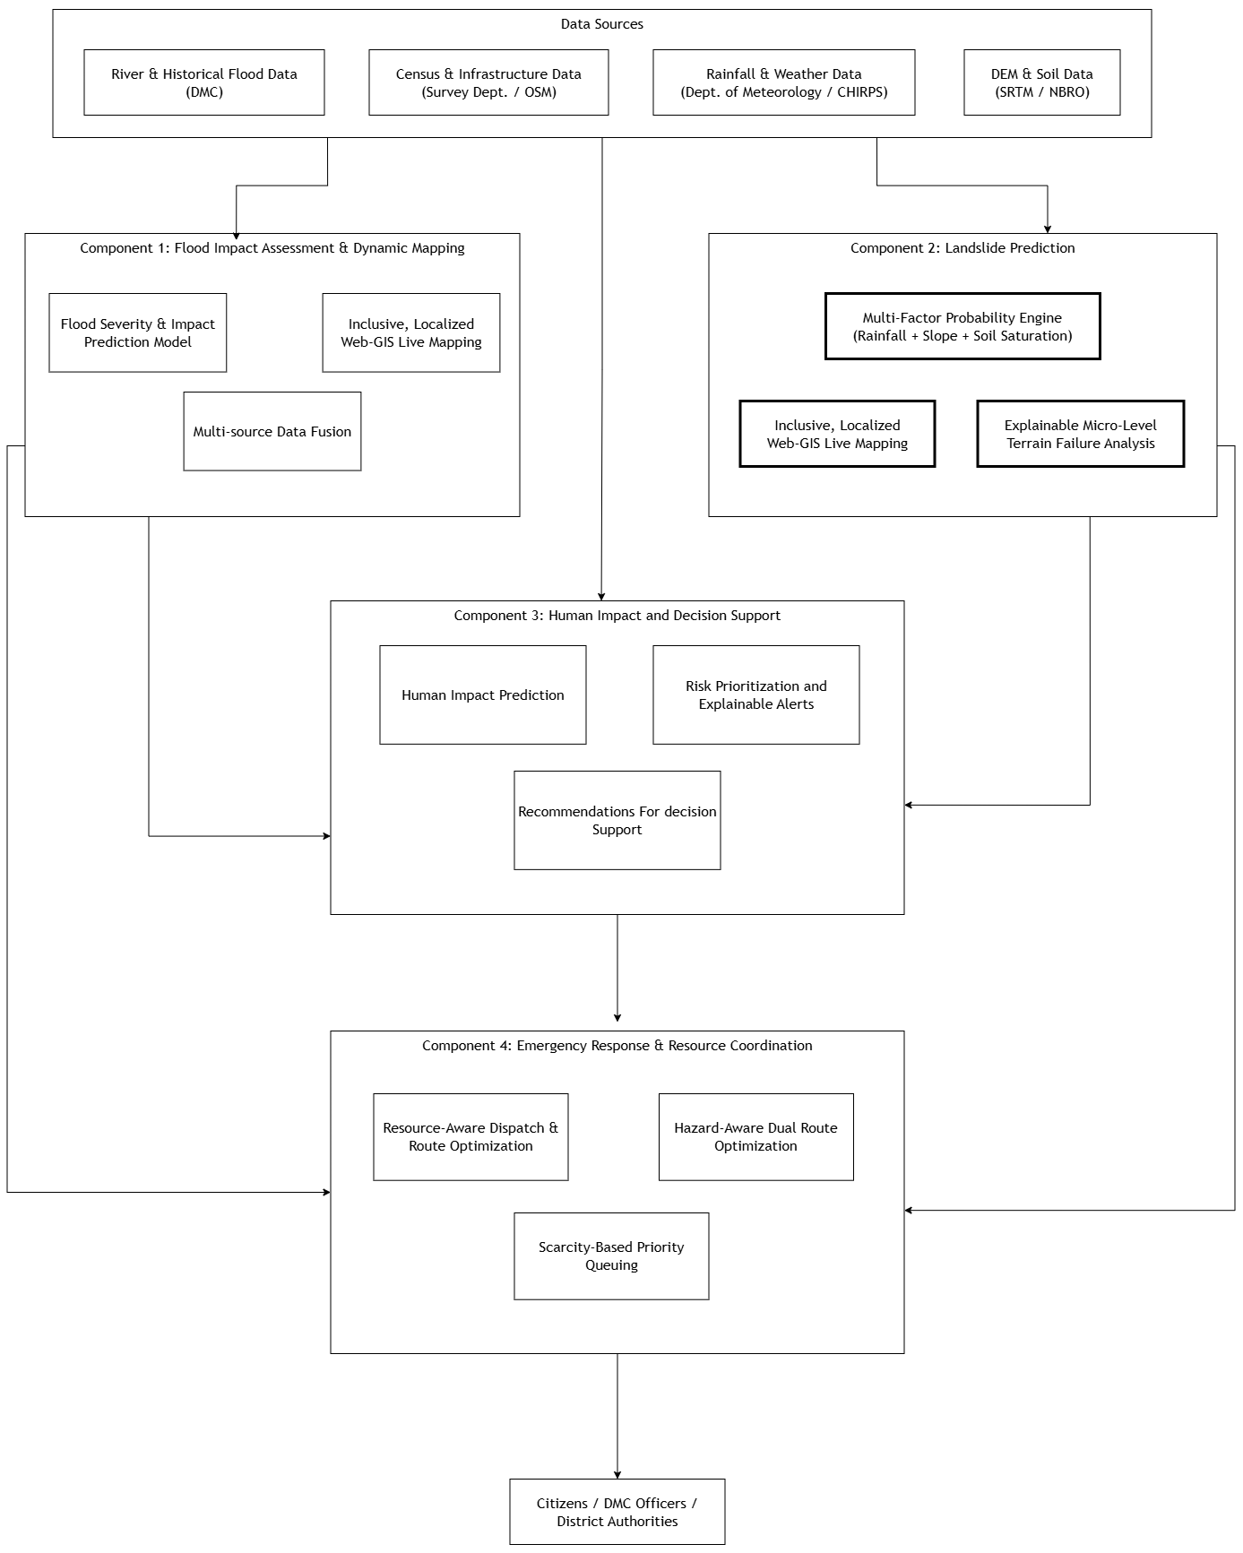

Figure 3.architecture diagram, black-and-white, own component highlighted

4.3 Individual Component
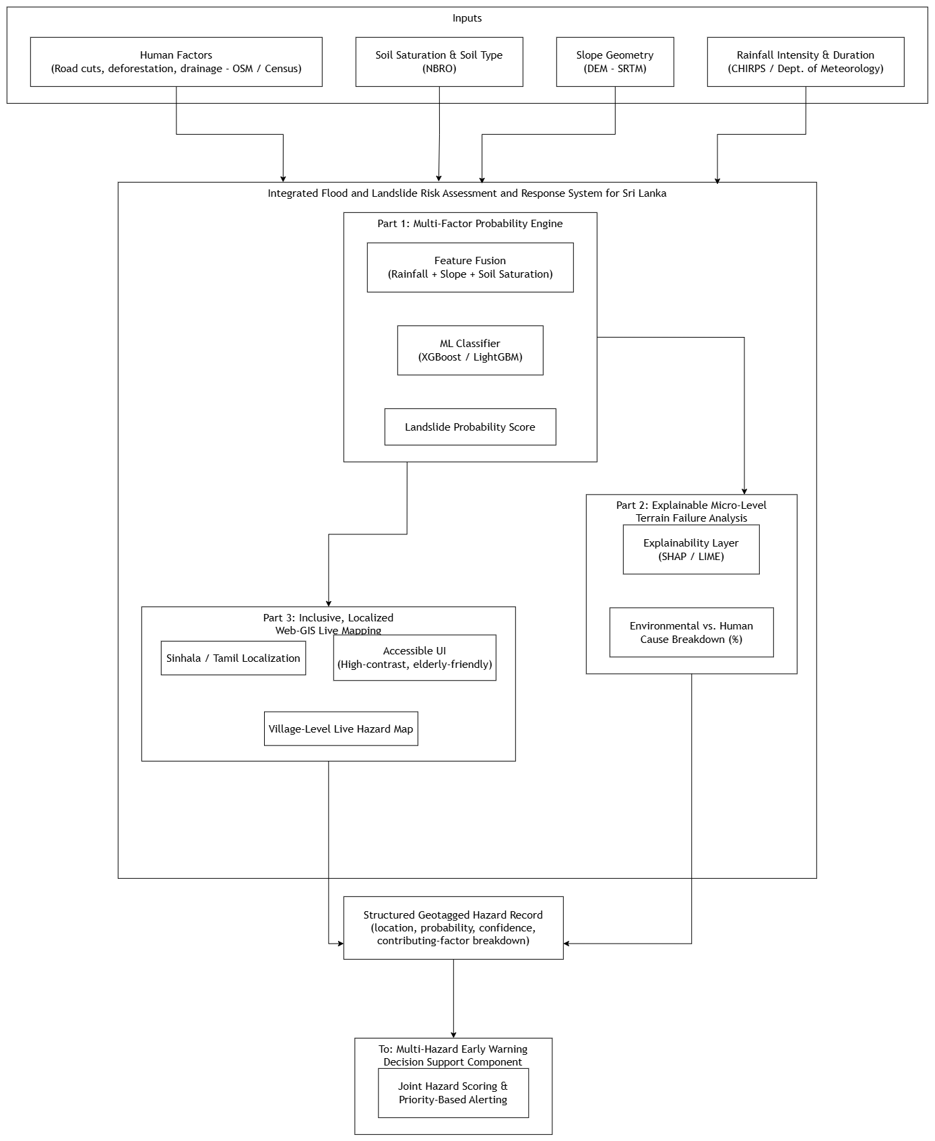

Figure 4.System Architecture Diagram Integrated Flood and Landslide Risk Assessment and Response System for Sri Lanka

4.4 Overall Integration
How the four components form a complete solution: Each component solves one link in the response chain, and none is independently sufficient. The Flood and Landslide components only produce hazard likelihoods, the Decision Support component only prioritizes, and Emergency Response only acts. Only in sequence do they constitute an end-to-end early-warning-to-response system.
Dependencies: The Decision Support component has a hard input dependency on both the Landslide and Flood components' hazard outputs - it cannot compute a joint, multi-hazard risk score without both. Emergency Response, in turn, depends entirely on Decision Support's prioritized alert output; it does not consume raw hazard scores directly. The Landslide and Flood components are themselves independent of one another (no cross-dependency), which allows them to be developed, tested, and iterated in parallel.
Integration method: Components communicate through a standardized REST API contract, exchanging structured JSON records rather than sharing internal state, complemented by a common PostGIS spatial database for shared geospatial layers (DEM, administrative boundaries, road networks). This mirrors the metadata-driven, agent-boundary design used in ResQConnect, where each specialized module (metadata extraction, retrieval, routing) exchanges only a defined, minimal data contract with the next stage rather than exposing internal reasoning, which keeps components loosely coupled and independently upgradable [ResQConnect]. This integration approach was deliberately chosen so that this author's Landslide Prediction component can be developed and validated in isolation using historical/simulated data, then plugged into the shared pipeline once its output schema is finalized, directly addressing the screening panel's feedback that overlapping responsibilities between components (particularly around Component 4) needed clearer separation, which this API-contract-based integration enforces structurally [13][14].

4.5 Individual Responsibility Boundary

Activity / Deliverable | My Responsibility | Shared Responsibility | Other Member
Multi-factor landslide probability model (rainfall + slope + soil saturation) | ✓
Explainable AI layer (SHAP/LIME) for terrain failure cause breakdown | ✓
Localized, accessible Web-GIS live mapping for landslide risk | ✓
Digitizing human factors (road cuts, deforestation) for pilot area | ✓
Data request to DMC/NBRO (landslide, decision support, emergency response components) |  | ✓
Shared PostGIS spatial database schema and setup |  | ✓
Standardized hazard-record API contract (output format consumed by Decision Support) |  | ✓
Flood severity & impact prediction model |  |  | Sinhalagoda S.A.U.R.A.V
Joint hazard scoring & priority-based alert generation |  |  | Prathibhani Y.L.O.L
Resource-aware dispatch & route optimization |  |  | Palihena M B

5. USER REQUIREMENTS

5.1 Evidence-Gathering Activities
Stakeholder discussions and domain-expert consultation: A formal data request letter was submitted to the Director General of the Disaster Management Centre (DMC), following guidance from Ms. Samanmali Matharaarachchi (Assistant Director, R&D), covering historical landslide records, rainfall data, and soil information for the landslide, decision-support, and emergency-response components. This engagement surfaced two recurring institutional pain points directly relevant to the Landslide Prediction component: (i) landslide-related data is currently scattered across NBRO, the Department of Meteorology, and DMC with no unified [15] access point, and (ii) existing hazard information is issued at a broad, regional or district scale rather than at the village/DS-division level that would be actionable for evacuation decisions.[14]
Domain-expert/literature evidence: Brenning's comparative review of landslide susceptibility classifiers highlighted that many published models report only "apparent" (training-set) error rates, which are misleadingly optimistic, and recommended models validated on independent, spatially separated test data to avoid overfitting [Brenning, 2005]. This directly informs a requirement for out-of-sample validation in the proposed model. Separately, the Kegalle District AHP-based study demonstrated that combining multiple triggering factors (rainfall, slope, soil, land cover, distance to river) raised classification accuracy from 50–70% (rainfall alone) to 86% (multi-factor) [Gunasinghe et al., 2023], evidencing user/institutional need for multi-factor rather than single-factor prediction.
Design-thinking / accessibility consideration: Reviewing NBRO's existing public tools (e.g., LIRIS) and government early-warning practice showed that current landslide-hazard outputs are typically presented in technical, English-only formats, which are not usable by elderly residents or non-technical village-level authorities in high-risk rural districts such as Nuwara Eliya, motivating the localization and accessibility requirements below.

5.2 Translated System Requirements

Functional Requirements
- The system shall ingest historical landslide records, rainfall data, slope/soil data, and land-use data from NBRO, the Department of Meteorology, and open geospatial sources (SRTM, OSM).
- The system shall compute a landslide probability score for a given location using a multi-factor model combining rainfall intensity/duration, slope geometry, and soil saturation.
- The system shall classify predicted landslide risk into discrete categories (e.g., Very Low, Low, Moderate, High, Very High), consistent with established susceptibility-mapping conventions.
- The system shall generate an explainable breakdown of each prediction, showing the relative contribution of environmental factors (rainfall, slope, soil) versus human factors (road cutting, deforestation, drainage obstruction).
- The system shall display predictions on a Web-GIS live map at village/DS-division granularity for the pilot area (Ambagamuwa, Kotmale, Walapane).
- The system shall support map interface localization in Sinhala and Tamil.
- The system shall output a structured, geotagged hazard record (location, probability, confidence, contributing-factor breakdown) consumable by the Decision Support component via a defined API contract.
- The system allows authorized users (e.g., NBRO/DMC officers) to view historical prediction accuracy against confirmed landslide events for a given area.

Non-Functional Requirements

- Response time: The system shall return a landslide-probability prediction for a queried location within 5 seconds under normal network conditions.
- Reliability: The prediction model shall achieve a minimum out-of-sample (spatially independent) accuracy of 80%, evaluated using held-out test regions rather than training-area accuracy alone, consistent with the extra-domain validation approach recommended by Brenning (2005).
- Usability: At least 90% of test users unfamiliar with GIS tools shall be able to identify their village's current risk level on the map interface within 2 minutes, without prior training.
- Accessibility: The map interface shall meet WCAG 2.1 AA color-contrast requirements and support high-contrast display modes for users with low vision, including elderly residents.
- Scalability: The system shall support prediction requests across all DS divisions in the pilot district (Nuwara Eliya) without degradation in response time beyond the 5-second threshold specified above.
- Security: All data exchanged with the Decision Support component via the API shall use authenticated, encrypted (HTTPS/TLS) connections.

6. COMMERCIALIZATION PLAN

6.1 Target Market and Customer Persona

Primary market (paying customer): Government disaster-management bodies in Sri Lanka: the Disaster Management Centre (DMC), National Building Research Organization (NBRO), and District/Divisional Secretariats in landslide-prone districts (Nuwara Eliya, Kegalle, Badulla, Ratnapura).

Persona 1: “The District DMC Officer": A mid-level government official responsible for issuing early warnings and coordinating evacuation across several DS divisions. Currently relies on manually compiled rainfall bulletins and static NBRO hazard maps; needs real-time, village-level risk visibility and defensible, explainable justification for evacuation orders.

Secondary market (non-paying, indirect beneficiary): Citizens in high-risk rural villages (e.g., Ambagamuwa, Kotmale, Walapane), particularly elderly residents and those without technical literacy, who need to understand their own risk level in plain, localized language.

Tertiary market (future/adjacent): NGOs and international disaster-response agencies (UNDRR, Red Cross) operating in Sri Lanka, who may license aggregated hazard analytics for programmed planning.

6.2 Value Proposition

For government agencies: a single, explainable, village-level landslide risk system that replaces scattered manual processes across NBRO/DMC/Meteorological, reduces the time from rainfall event to actionable warning, and provides an auditable breakdown of why a given area is flagged high-risk (supporting accountability when evacuation decisions are challenged).
For citizens: a free, localized, accessible way to check their own area's risk without needing to interpret technical hazard maps.

6.3 Revenue Model

- B2G licensing/SaaS subscription: Annual or multi-year license fee paid by DMC/NBRO (or funded via a government IT procurement budget) for access to the platform, dashboards, and historical accuracy reporting.
- Grant/donor-funded deployment: Given the good public nature of disaster response, initial deployment could be funded through World Bank, UNDP, or ADB disaster-resilience grants, or Sri Lanka's own disaster-risk-reduction budget lines, rather than pure commercial sales.
- Free citizen tier: The public-facing Web-GIS map and mobile alerts remain free to citizens this isn't a revenue line, it's the public-good delivery mechanism that justifies government funding.
- Optional data/API licensing: Aggregated hazard analytics could be licensed to NGOs or research institutions for a fee, as a secondary revenue stream once the core system is established.

6.4 Cost Estimation

- Development cost: Team time (final-year project, largely sunk/academic at this stage)
- Infrastructure cost: Cloud hosting (API + PostGIS database + model inference), scaling with the number of districts covered; estimate based on typical small-scale GIS SaaS hosting (e.g., a few hundred USD/month for a pilot district, scaling per district added).
- Data acquisition cost: Largely free/negligible, since core data (NBRO, DMC, SRTM, CHIRPS) is either government-provided under MOU or open-access.
- Maintenance cost: Ongoing model retraining, localization updates, and support staff time.

6.5 Pricing Strategy
- Tiered government licensing: e.g., a per-district or per-DS-division annual license fee, so a smaller district authority pays less than DMC's national-level access.
- Pilot-then-scale pricing: Offer the first pilot district (Nuwara Eliya) at no or reduced cost to build a credible case study, then price subsequent district rollouts commercially.
- Free forever citizen access: Explicitly non-negotiable citizen-facing information should never be paywalled, both ethically and because government buy-in depends on public benefit being visible.

6.6 Competitive Advantage
- Multi-factor + explainable prediction, versus NBRO's current LIRIS system, which is largely informational/static rather than predictive and explainable at village level.
- Localization and accessibility (Sinhala/Tamil, elderly-friendly UI) is a gap not addressed by existing technical hazard-mapping tools.
- Integration into a broader multi-hazard platform (via the Decision Support and Emergency Response components), rather than being a standalone landslide tool; this is your differentiation versus single-purpose academic landslide-susceptibility studies like Brenning (2005) or the Kegalle AHP study (Gunasinghe et al., 2023), which produce static maps but no live decision-support pipeline.

6.7 Intellectual Property Considerations
- The trained ML model, explainability configuration, and Web-GIS interface code constitute the team's own IP, developed independently of the underlying open data sources.
- Underlying datasets (NBRO, Department of Meteorology, SRTM, CHIRPS) remain the property of their respective source organizations/agencies; commercialization would require formalizing data-usage terms with NBRO/DMC beyond the current academic data-request letter, likely a data-sharing MOU rather than outright data ownership.
- Any government deployment would likely require a licensing agreement clarifying whether DMC/NBRO receives exclusive rights, a non-exclusive license, or co-ownership. Given they are both the data provider and the primary customer, this is worth flagging explicitly in the report as an open consideration rather than assuming a clean-cut answer.

7.BUDGET AND JUSTIFICATION

7.1 Hardware Costs
Item | Estimated Cost (LKR) | Justification
Laptop/workstation (existing, team-owned) | 0 (sunk cost) | Model training, GIS digitizing, and frontend development performed on existing personal devices; no new hardware purchase required for the academic phase.
GPU compute (cloud, pay-as-you-go, if needed) | 5,000 -15,000 (one-time, during model training phase) | XGBoost/LightGBM training on tabular geospatial features is CPU-feasible; GPU only needed if experimenting with deep-learning alternatives (e.g., CNN on raster DEM tiles) budgeted as optional/contingency.
Mobile test device (Samsung/mid-range Android, for Web-GIS UI accessibility testing) | 0 (existing personal device used) | Needed to validate the high-contrast, elderly-friendly UI on real mobile hardware rather than desktop browser emulation only.

7.2 Software Licenses
Item | Estimated Cost (LKR) | Justification
QGIS | 0 (open source) | Used for GIS digitizing human factors (road cuts, drainage) no license cost as it is free/open-source software.
PostgreSQL + PostGIS | 0 (open source) | Spatial database backend for storing hazard records and geospatial layers; no license cost.
Python ML libraries (XGBoost, LightGBM, SHAP, scikit-learn) | 0 (open source) | All core modelling and explainability libraries are open source with no licensing fee.
React.js / Tailwind CSS / MapLibre GL JS / Leaflet | 0 (open source) | Frontend and mapping libraries are all open source; no license cost.
i18next / react-i18next and React Native | 0 (open source) | Localization framework for Sinhala/Tamil UI support; open source.
GitHub (private repo, student plan) | 0 (open source) | Version control and collaboration; covered under GitHub Student Developer Pack.

7.3 Cloud Services
Item | Estimated Cost (LKR) | Justification
Cloud hosting for API + PostGIS database (e.g., small VM instance) | 3,0006 -,000/month during active development/testing | Required to host the model inference API and spatial database so the Decision Support component (teammate) can integrate with it during development, rather than relying on local-only testing.
Object storage (satellite imagery, DEM tiles, model artifacts) | 1,000 -2,000/month | DEM (SRTM), CHIRPS rainfall grids, and trained model files require persistent storage beyond local disk, especially for reproducibility and team access.
Google Earth Engine (data access) | 0 (free research/academic tier) | Used for satellite imagery access; free under Earth Engine's non-commercial research license.

7.4 Summary Justification
The budget is deliberately weighed toward human effort rather than hardware or licensing, since the component's architecture relies entirely on open-source tooling (QGIS, PostGIS, Python ML stack, React/Leaflet) consistent with keeping the solution replicable and low-cost for eventual government adoption (Section 6.4, cost estimation). The only recurring real expense is cloud hosting during active development and team integration testing, which is necessary because the Decision Support component depends on querying your API live rather than through static exports.

WORK BREAKDOWN STRUCTURE (WBS)

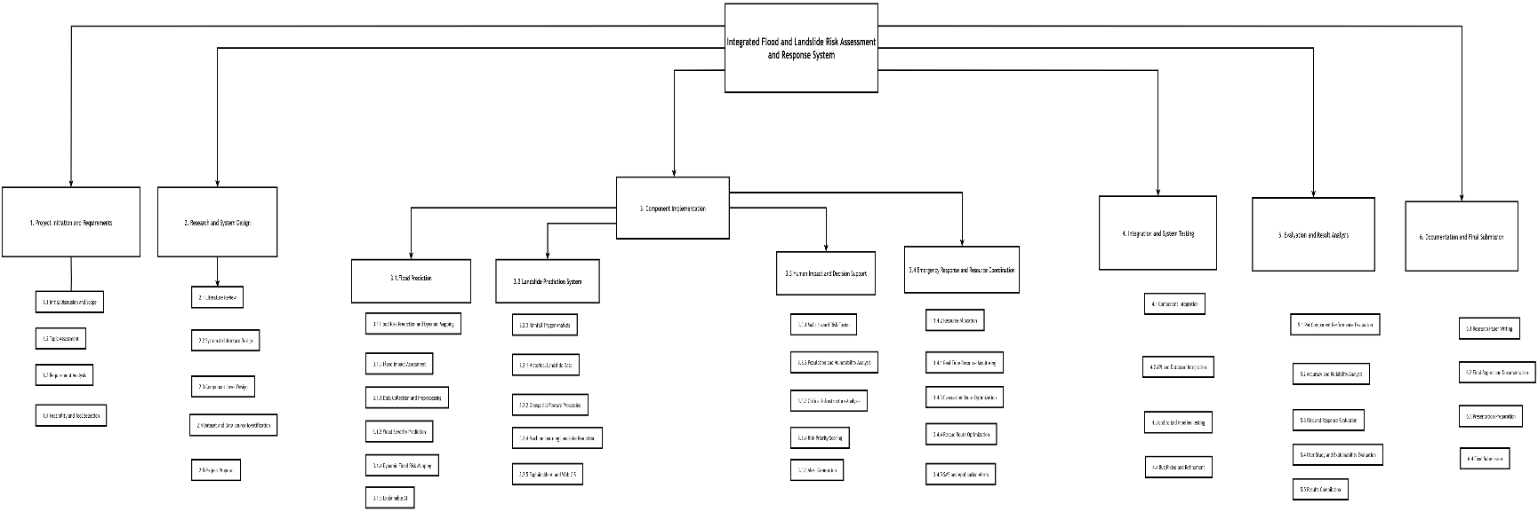

Figure 5.Work Break Down Chart for Whole System

GANTT CHART
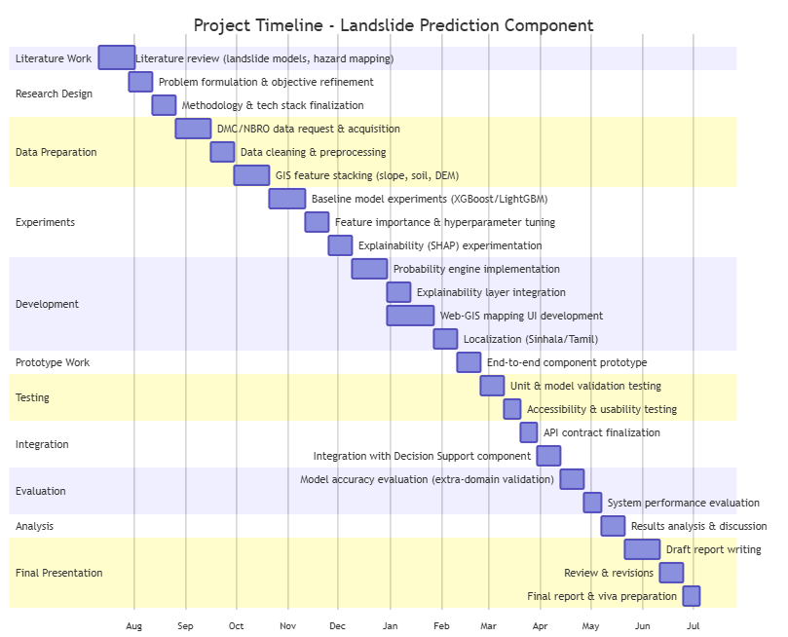

Figure 6.Gaant Chart Of my Component
10. REFERENCES LIST
[1] K. Gaidzik and M. T. Ramírez-Herrera, "The importance of input data on landslide susceptibility mapping," Sci. Rep., vol. 11, art. no. 19334, 2021, doi: 10.1038/s41598-021-98830y.
[2] A. Brenning, "Spatial prediction models for landslide hazards: review, comparison and evaluation," Nat. Hazards Earth Syst. Sci., vol. 5, pp. 853–862, 2005.
[3] L. Gunasinghe, L. Gunawardhana, and L. Rajapakse, "Predictive analysis of landslide susceptibility under hydrological aspects of climate change in Kegalle District, Sri Lanka," in Proc. 2023 Moratuwa Eng. Res. Conf. (MERCon), Colombo, Sri Lanka, 2023, pp. 119–124, doi: 10.1109/MERCon60487.2023.10355394.
[4] National Building Research Organisation, "Landslide early warning issued," NBRO, Colombo, Sri Lanka. [Online]. Available: https://www.nbro.gov.lk
[5] UN Office for the Coordination of Humanitarian Affairs (OCHA) and UN Resident Coordinator's Office (RCO), "Cyclone Ditwah – situation report (23 January 2026)," United Nations Sri Lanka, Colombo, Sri Lanka, Jan. 2026. [Online]. Available: https://srilanka.un.org/en/308868-cyclone-ditwah-situation-report-23-january-2026
[6] Disaster Management Centre, Sri Lanka, "Landslide warning/situation reports," DMC, Colombo, Sri Lanka. [Online]. Available: https://www.dmc.gov.lk (accessed Sep. 12, 2026).
[7] S. Rathnayaka, "Landslide Susceptibility Component," GitHub Pages, 2026. [Online]. Available: https://sadumina.github.io/Landlside-Suceptability-Component/
[8] "Landslide hazards assessment in Nuwara Eliya District in Sri Lanka," 2018. [Online]. Available: https://www.researchgate.net/publication/322652881
[9] A. Sinhalagoda, "J26-IT-334: Datasets for Integrated Flood and Landslide Risk Assessment and Response System," GitHub repository, 2026. [Online]. Available: https://github.com/amasha-sinhalagoda/J26-IT-334
[10] Google, “Classification: Accuracy, recall, precision, and related metrics,” Google for Developers, 2024. https://developers.google.com/machine-learning/crash-course/classification/accuracy-precision-recall (accessed Sept. 13, 2026).
[11] S.Rathnayaka, “Component-Testing: Feature-Set Comparison, GitHub repository, 2026,” GitHub.com, 2026. https://github.com/sadumina/Component-Testing-.git (accessed Sept. 13, 2026).
[12] “3D Mappings,” GitHub.com, 2026. https://github.com/sadumina/Sri-Lanka-3D-map.git (accessed Sept. 13, 2026).
[13] draw.io, “draw.io - Diagrams for Everyone, Everywhere,” draw.io. https://drawio-app.com (accessed Sept. 13, 2026).
[14] A. Sinhalagoda, “Special Agreement for Data Requesting and Information Gathering,” GitHub.com, 2026. https://github.com/amasha-sinhalagoda/J26-IT-334/tree/Bagya---Docs/Special%20Agreements (accessed Sept. 13, 2026).
[15] A. Sinhalagoda, “Special Letter for Agriculture Department and NRBI In Sri Lanka,” GitHub.com, 2026. https://github.com/amasha-sinhalagoda/J26-IT-334/tree/Bagya---Docs/Signed%20Letters (accessed Sept. 13, 2026).
[16] S. Senanayake, B. Pradhan, A. Huete, and J. Brennan, “Assessing Soil Erosion Hazards Using Land-Use Change and Landslide Frequency Ratio Method: A Case Study of Sabaragamuwa Province, Sri Lanka,” Remote Sensing, vol. 12, no. 9, p. 1483, May 2020, doi: 10.3390/rs12091483.
[17] K. Zighmi et al., “AHP multi-criteria analysis for landslide susceptibility mapping in the Tellian Atlas chain,” Scientific Reports, vol. 15, no. 1, July 2025, doi: 10.1038/s41598-025-10819-z.
[18] H. Hemasinghe, R. S. S. Rangali, N. L. Deshapriya, and L. Samarakoon, “Landslide susceptibility mapping using logistic regression model (a case study in Badulla District, Sri Lanka),” Procedia Engineering, vol. 212, pp. 1046–1053, 2018, doi: 10.1016/j.proeng.2018.01.135.

APPENDICES

Appendix 1
Appendix A: Prototype Evidence
Integrated Flood and Landslide Risk Assessment and Response System for Sri Lanka Live demo: https://sri-lanka-3-d-map.vercel.app/
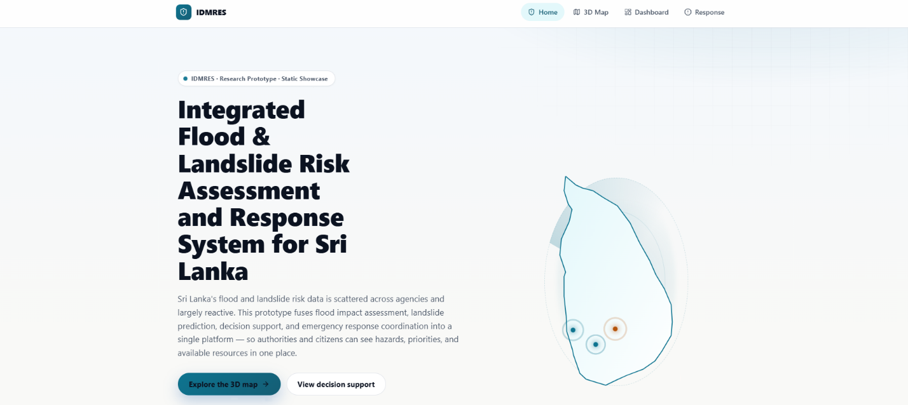

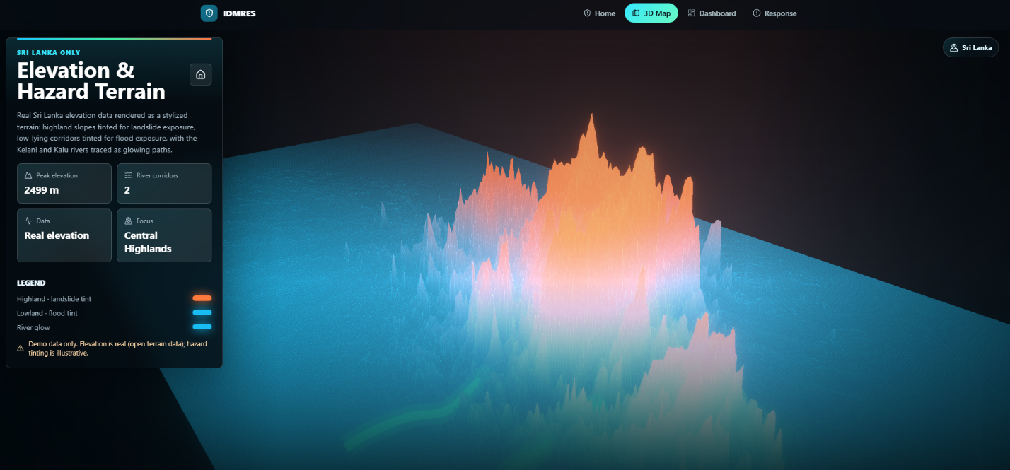

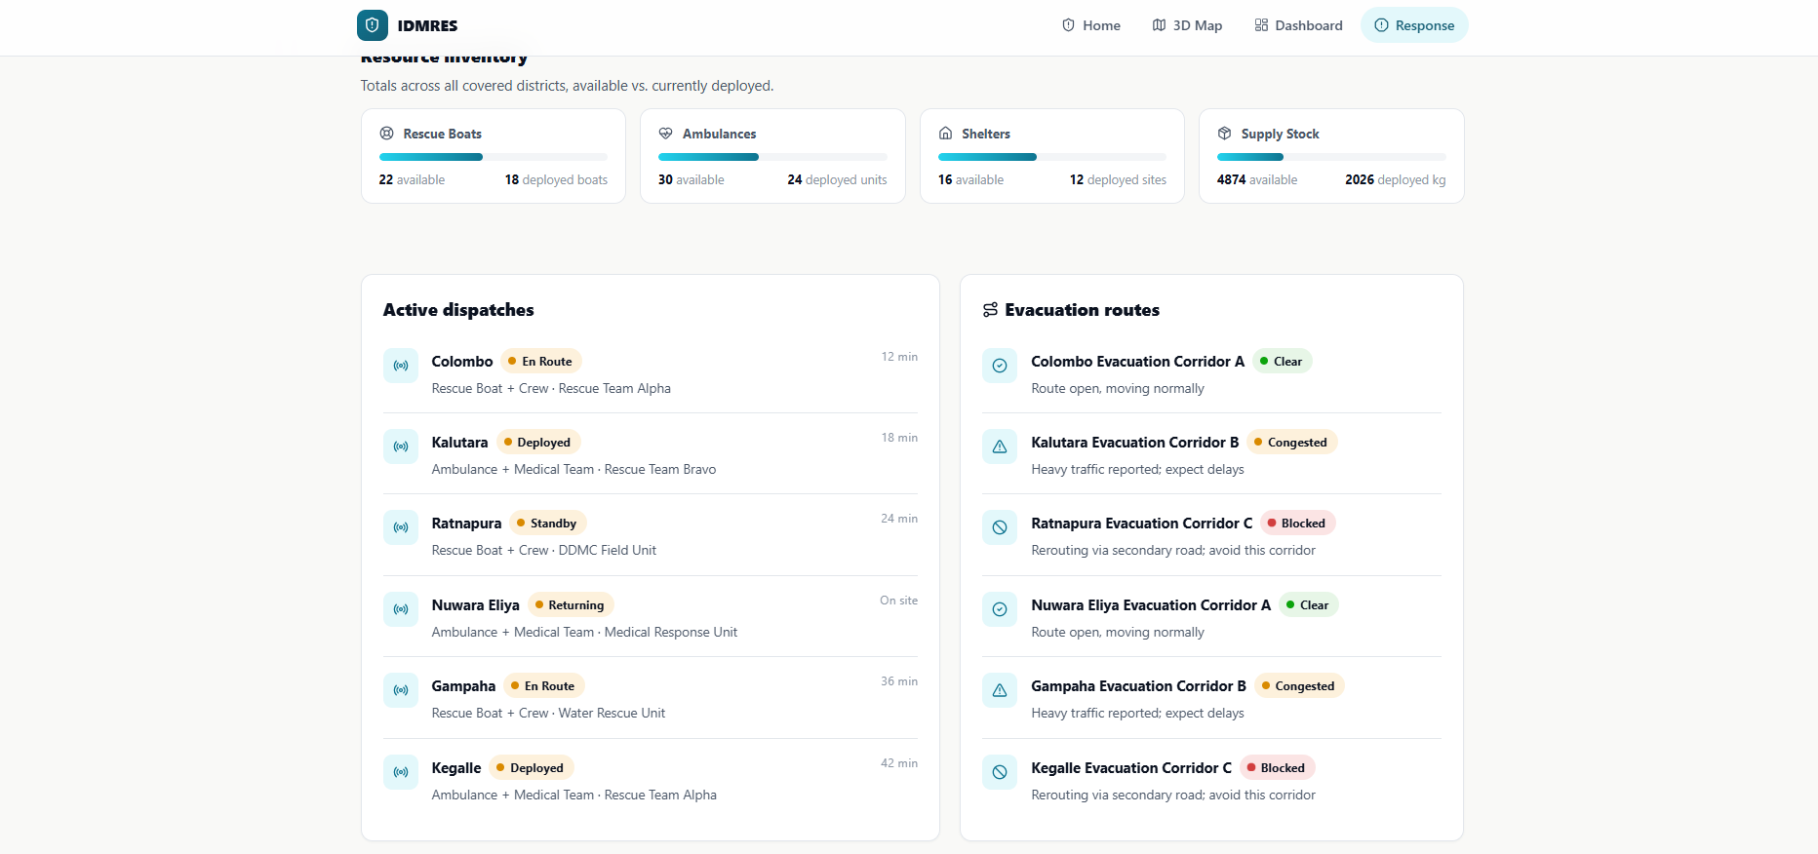
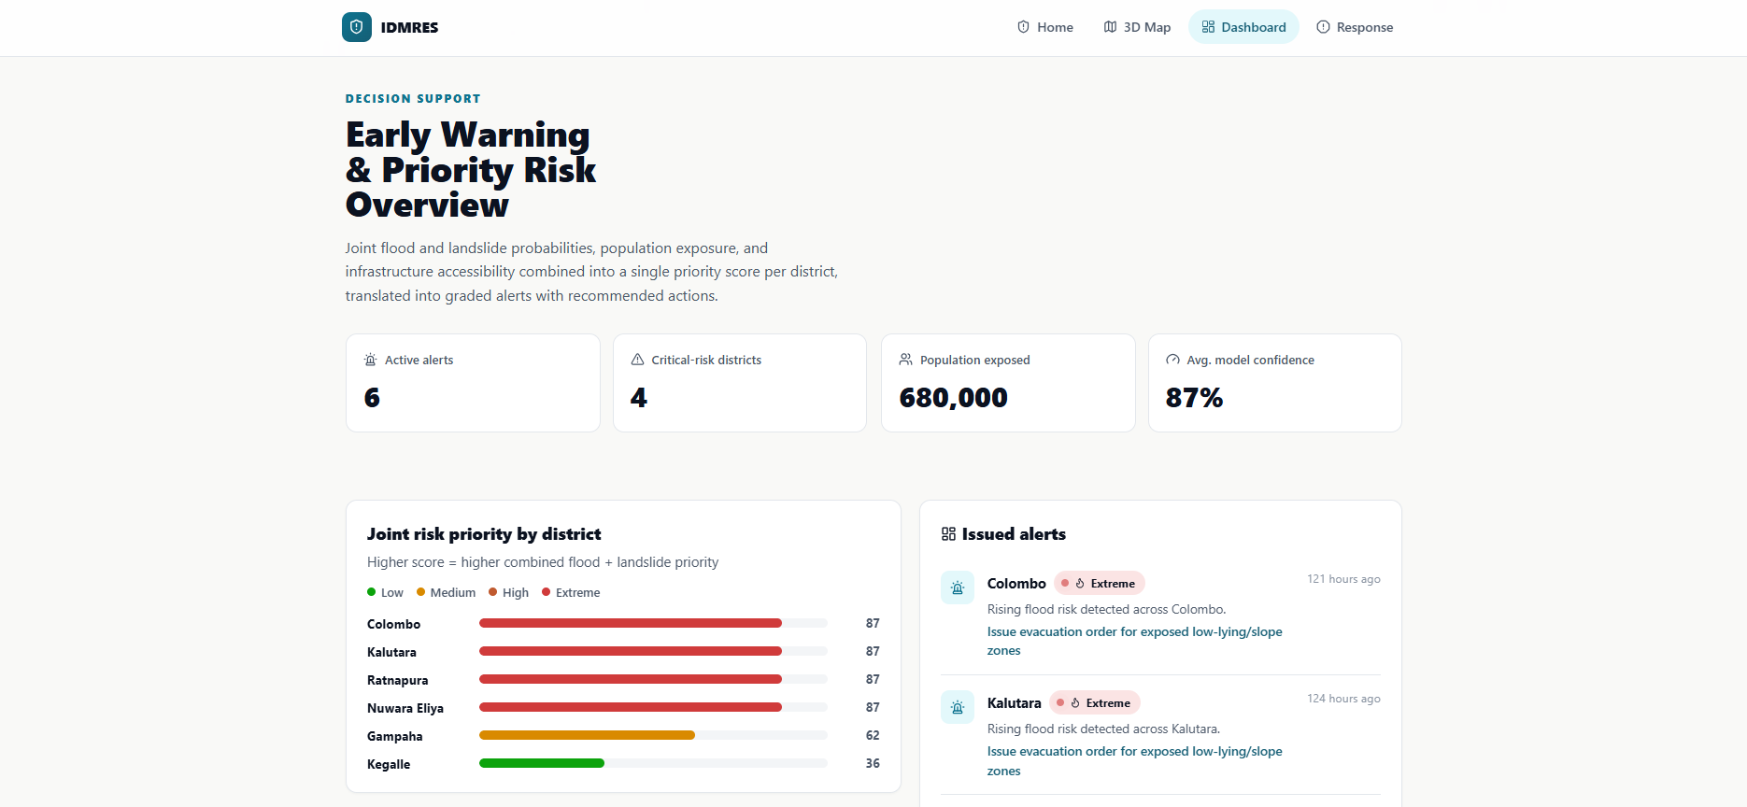

Appendix B: Prototype Evidence - Individual Component (Landslide Prediction)
Landslide Risk Framework Component Architecture Prototype
Live demo: https://sadumina.github.io/Landlside-Suceptability-Component/
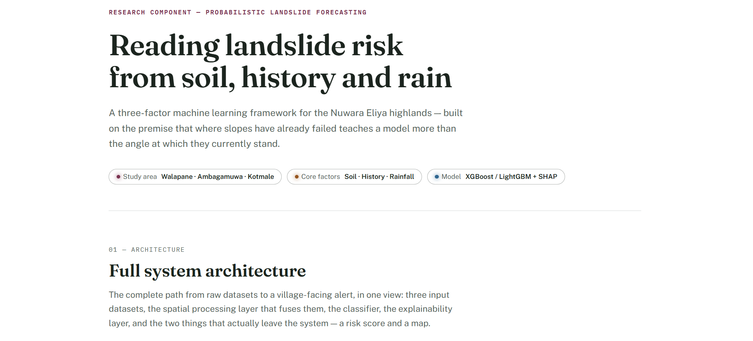

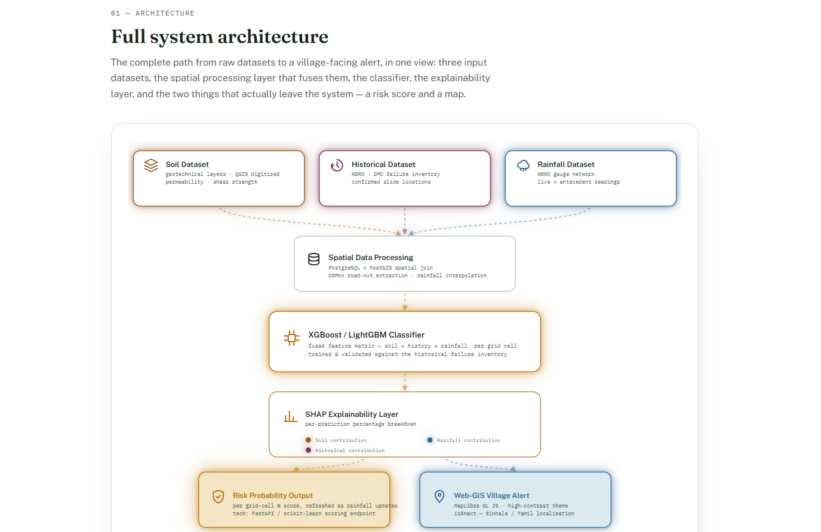

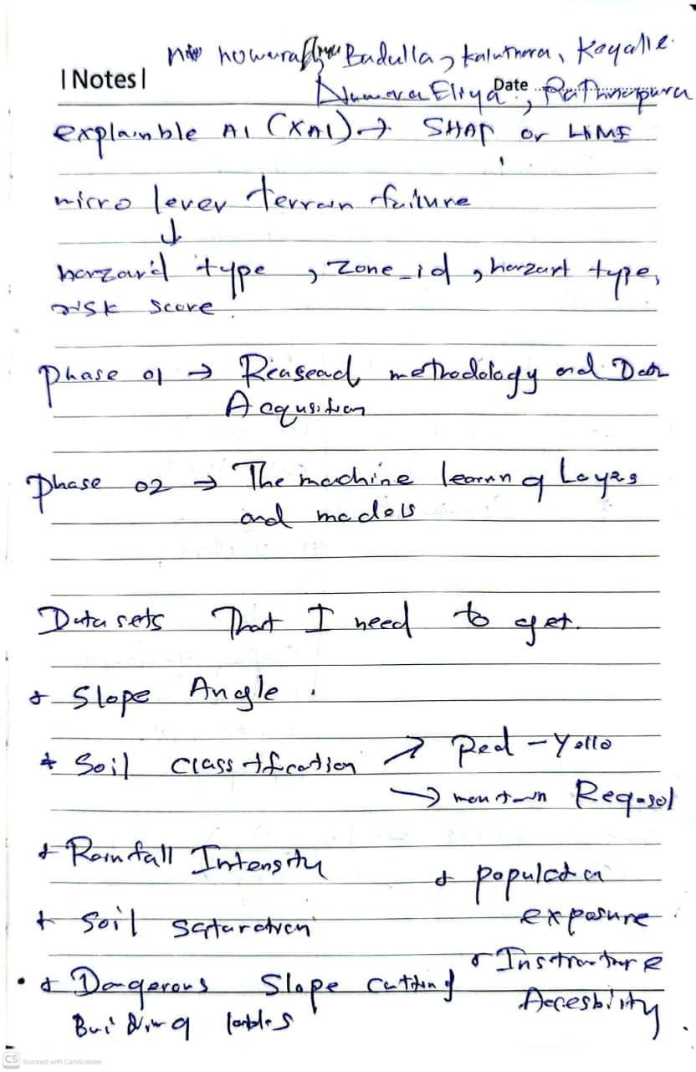
Appendix C: Preliminary Research Notes (Requirements Elicitation & Research Design)
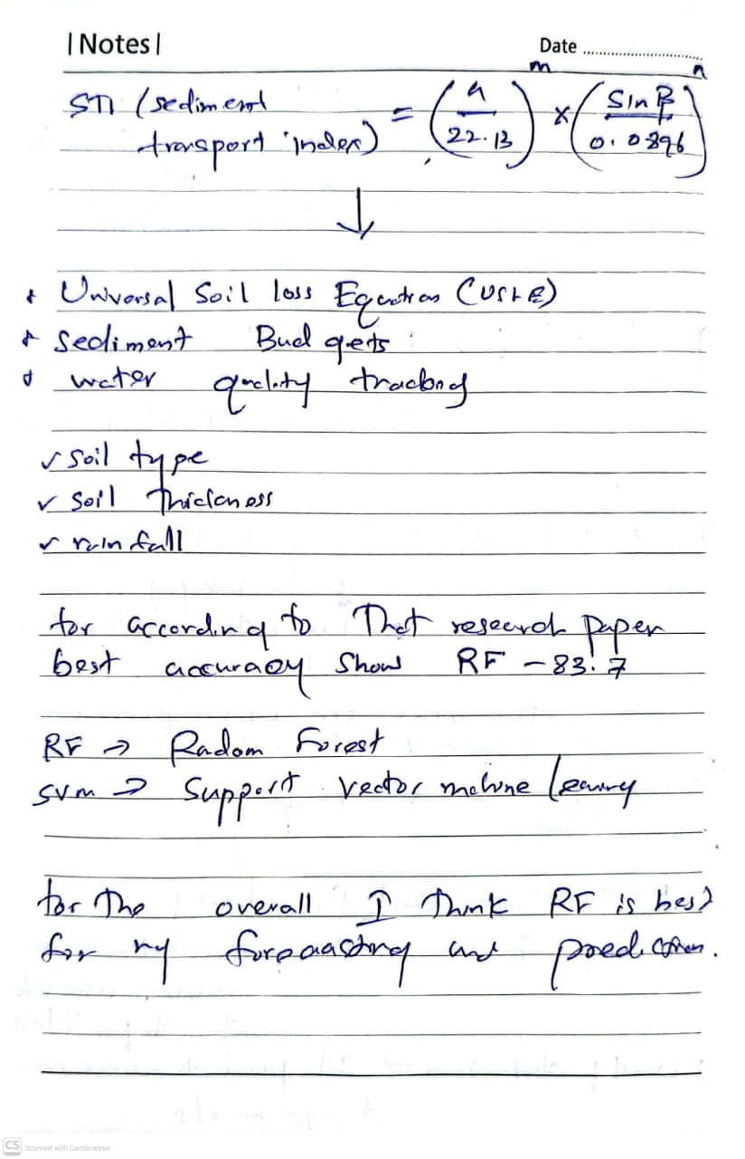
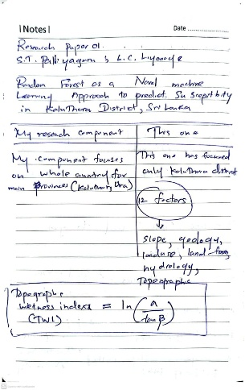
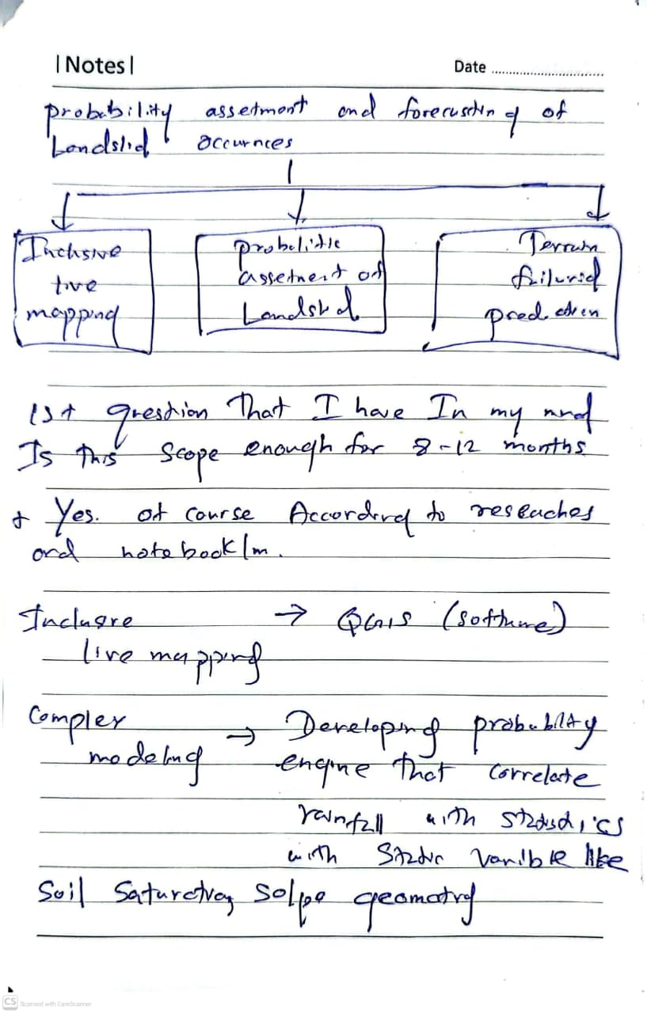
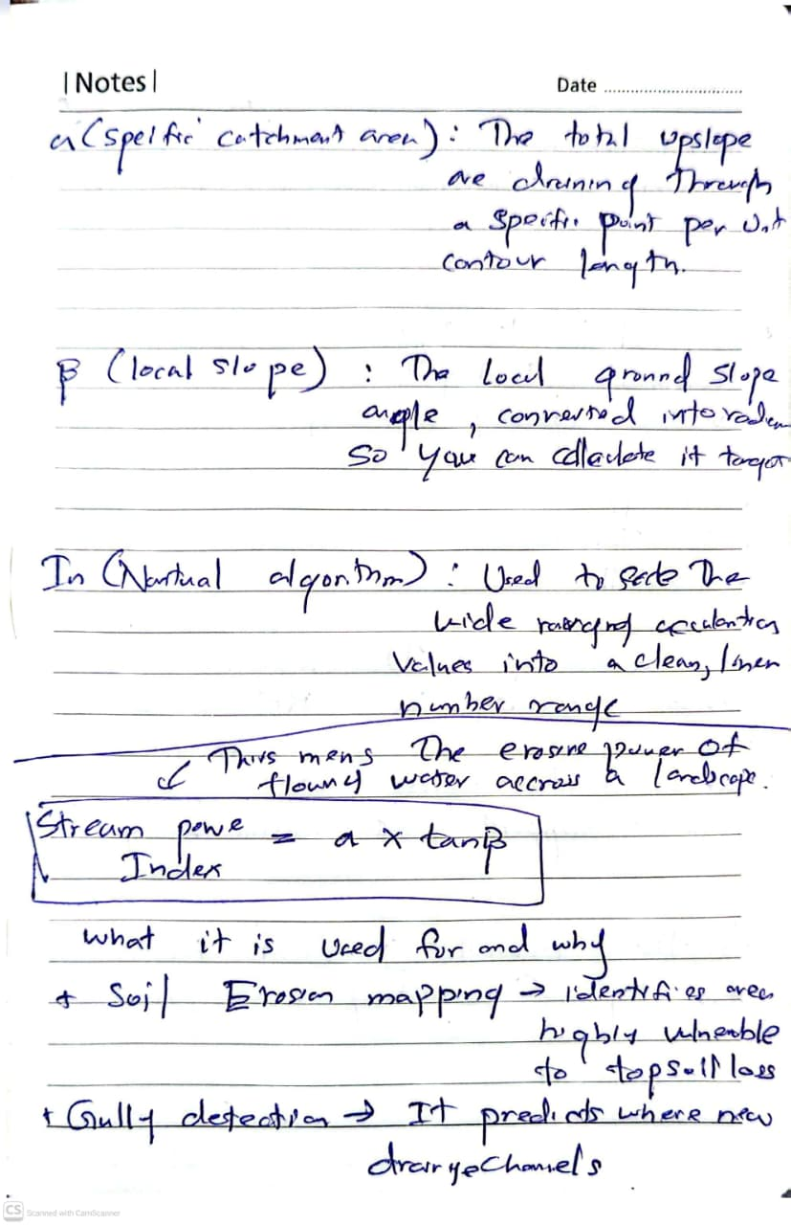

Appendix 2 - Mandatory Proposal Evidence and Decision Log
Each student should maintain the following log throughout proposal development.

Date | Claim / Problem | Evidence Collected | Alternatives Considered | Decision Made | Supervisor Discussion
Sep 02, 2026 | Evaluating Panel Feedback: Enhancing the real-time data acquisition layer of the system. | Proposal presentation defense before the Evaluating Panel. The panel approved the implementation phase but recommended evaluating the integration of physical IoT edge devices for field data collection. | 1. Directly proceed with the initial soft-data scope.  2. Immediately pivot the architecture to incorporate custom physical IoT hardware nodes. | Defer the final system architectural modification until a formal consult is conducted with the supervisory team to assess scope bloat and feasibility. | The panel granted conditional permission to implement the project while recommending the exploration of an IoT layer.
Sep 06, 2026 | Feasibility and Scope Validation of IoT Integration: Assessing the necessity of custom IoT hardware deployment. | Technical review of existing agency data assets. Confirmed that historical and current data pipelines from NBRO, DMC, and the Department of Meteorology already provide the necessary structural inputs. | 1. Develop and deploy physical IoT sensor networks in the field.  2. Rely strictly on existing state agency data infrastructures and historical inventories. | Exclude custom physical IoT hardware development from the project scope to maintain focus on machine learning modeling and explainability layers, given that the required telemetry data is already accessible. | Online Meeting with Supervisor: The supervisor advised against building custom IoT hardware, confirming that existing data sources fully cover the system inputs, avoiding redundant engineering efforts
Sep 12 – Sep 15, 2026 | Proposal Synthesis and Finalization: Consolidating panel recommendations and supervisor directives into the final baseline document. | Compiled all pre-proposal research, architectural specifications, WBS lifecycle structures, and the validated scope exclusions. | 1. Submitting the original unpolished report draft.  2. Restructuring the documentation to reflect the finalized scope agreements and log justifications. | Decision: Drafted and finalized the official Research Proposal Report, formally documenting the verified system scope, dataset architecture, and module integrations | The final technical report architecture was structured to align precisely with the guidelines provided by the supervisor and the requirements of the evaluation panel.

Appendix 3 - AI Use Disclosure
Students should disclose any use of generative AI tools during proposal preparation.

AI Tool | Purpose of Use | What Was Generated/Assisted | How Output Was Verified | Final Student Contribution
Claude AI | Brainstorming, structuring research gaps, and refining academic terminology. | Assisted in organizing initial concepts and aligning the research features with established academic writing standards. | Cross-referenced all suggested literature, methodologies, and framework names against official publications from international and national organizations (e.g., NBRO, DMC). | Maintained full ownership of the intellectual ideas, selected the final research direction, and wrote the comprehensive text of the proposal.
ChatGPT | Proofreading, syntax refinement, and grammatical correction. | Assisted in identifying and correcting grammatical errors, improving sentence structure, and enhancing overall text readability. | Manually reviewed every suggested phrasing change to ensure the technical accuracy and original meaning of the research were preserved. | Formulated the core technical arguments, compiled the datasets, and executed the comparative analysis of the landslide models.

